**Computer Networks**

**Assignment 01**

**Question 01**

**Part 1:  
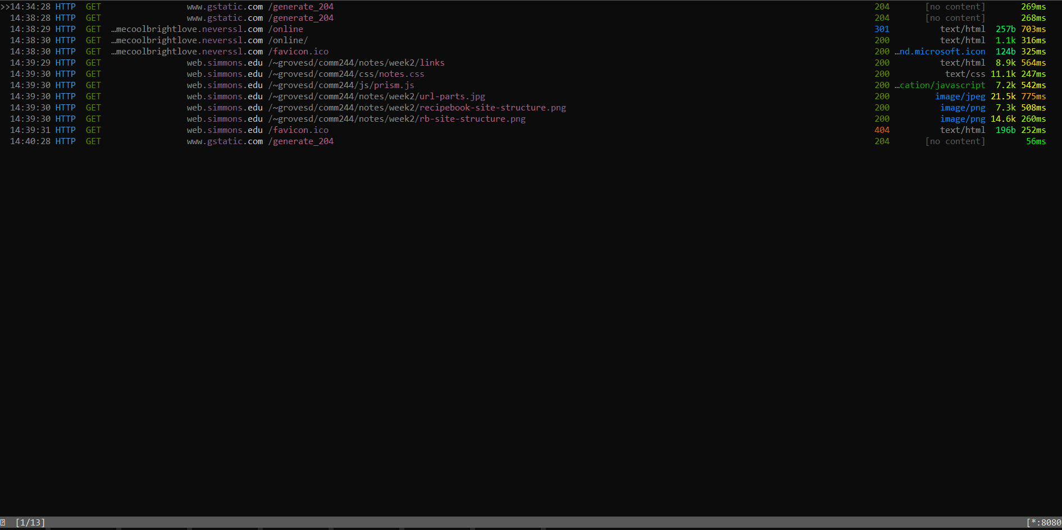**

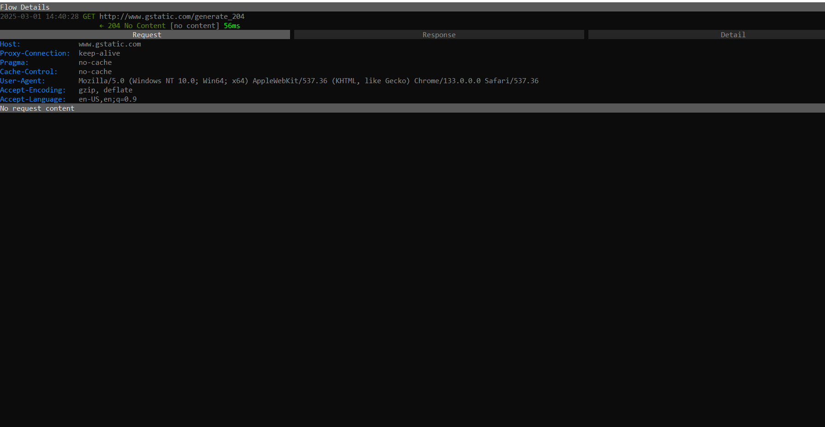

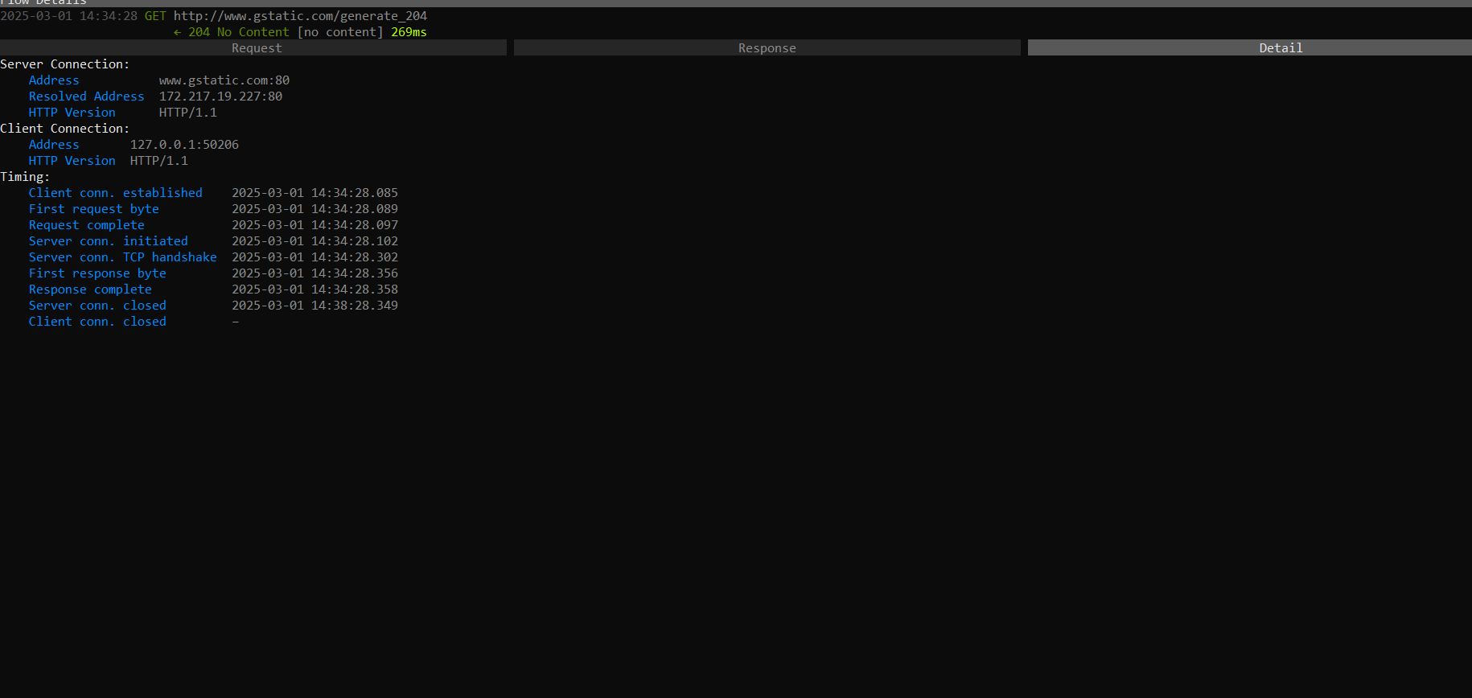

The request is made using HTTP instead of HTTPS, meaning the communication is unencrypted.

This exposes the data to Man-in-the-Middle (MITM) attacks, allowing attackers to intercept and modify the request.

The request does not contain any authentication tokens, API keys, or user credentials.

While this specific request (204 No Content) does not expose sensitive data, other requests to the same server might.

Risk: If a session-based authentication is used elsewhere, an attacker could hijack the session.

**Part 2:**

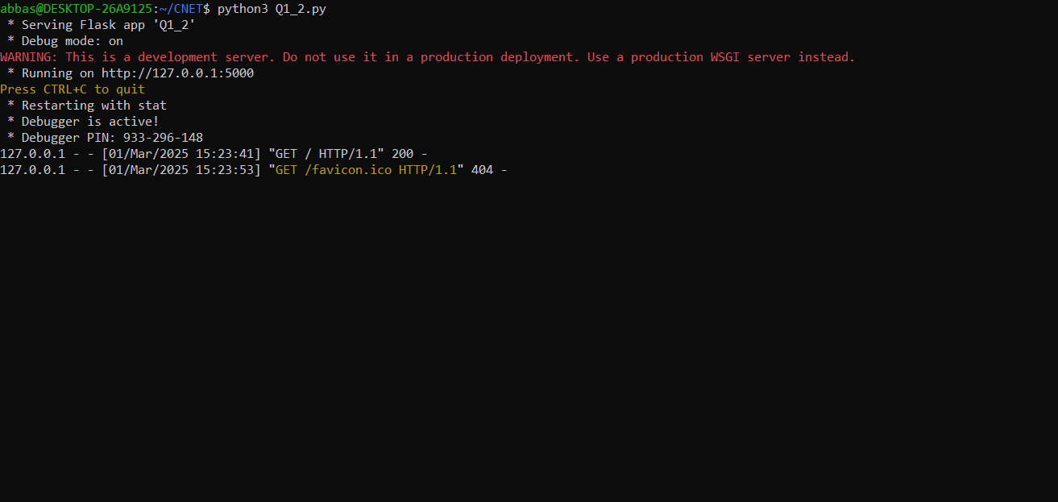

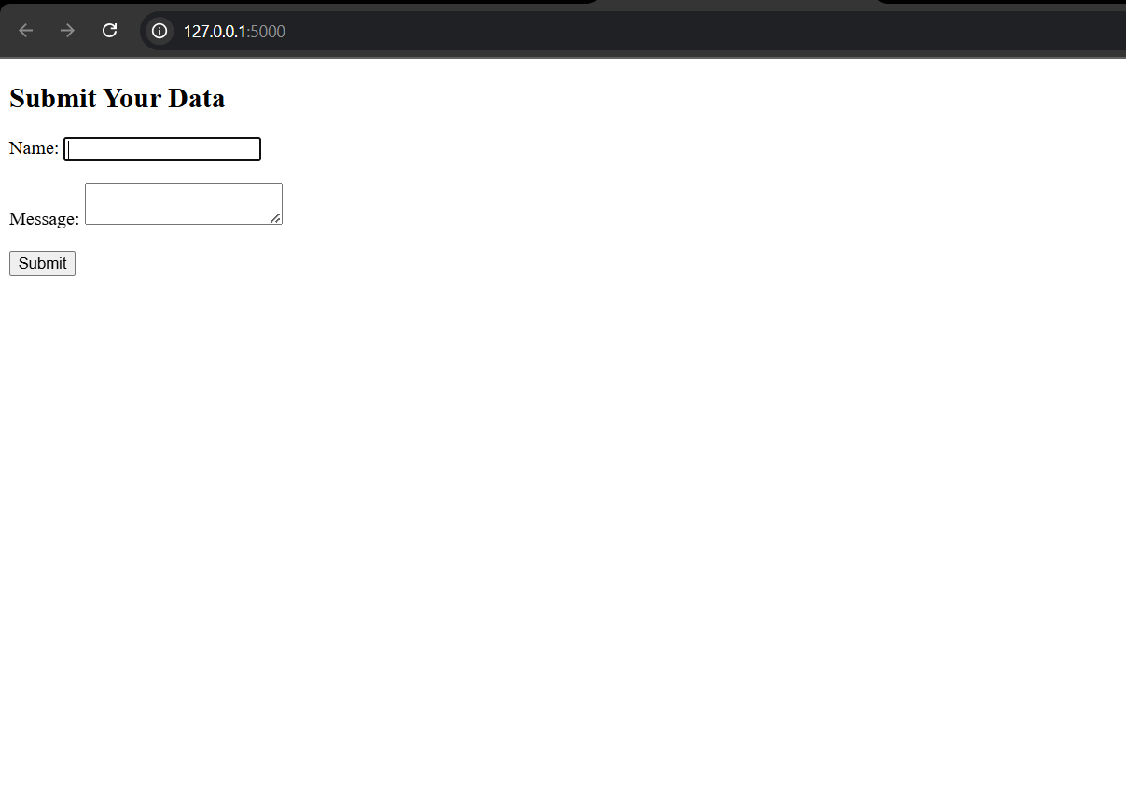

**Question 02**

**Part 1:  
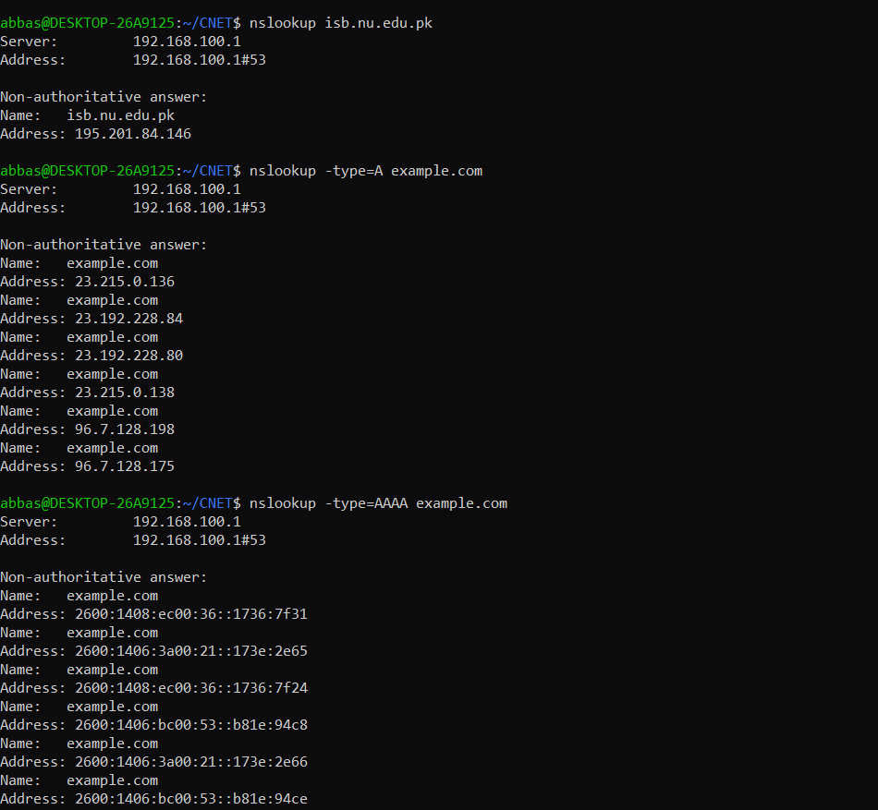**

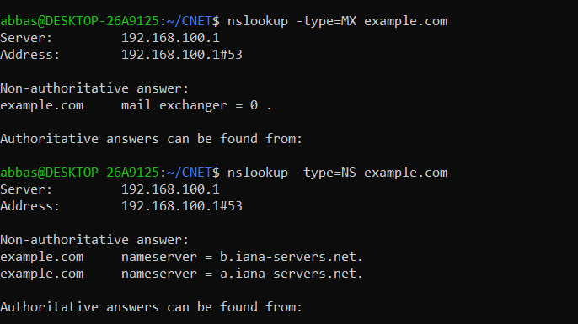

**Part 2:**

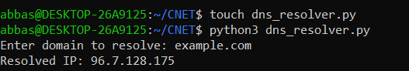

**Question 04**